University of Central Punjab, Lahore

Artificial Intelligence
BSCS-E10
Assignment-01
CLO | CLO STATEMENT | Bloom’s Taxonomy Level | PLO
1 | To understand and explain the solid fundamental principles and concepts of artificial intelligence, including machine learning and neural networks. | C2 | P1

Learning Objectives
- Apply and trace search algorithms (DFS, DLS, IDS, UCS) to solve problems and understand their execution process.
- Analyze and compare algorithm performance in terms of completeness, optimality, and efficiency.

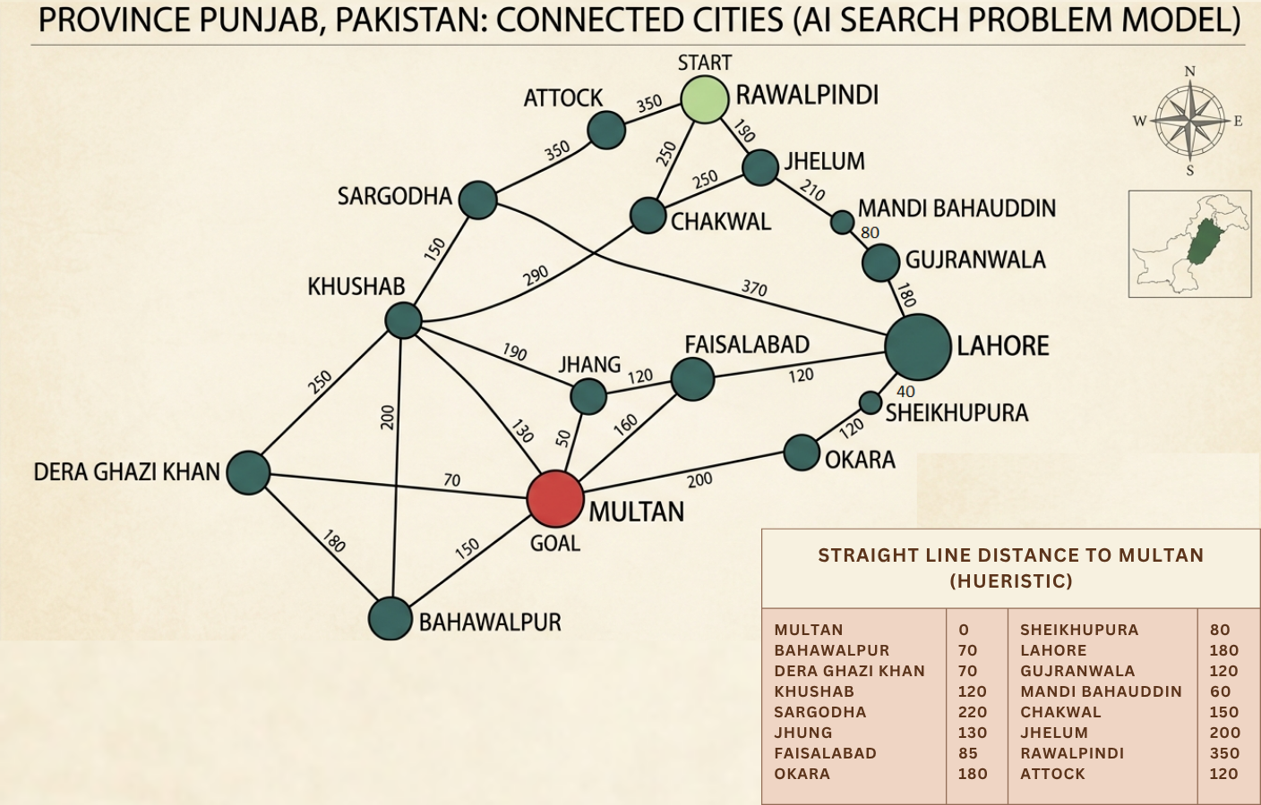

Part A: Uninformed Search (30 Marks)
Q1. Step-by-Step Execution ($10×3 Marks$)
Consider that
- Edges (Cost = 1 for all):
Tasks:
- Apply Depth First Search (DFS)
- Apply Depth Limited Search (DLS) with bound = 5
- Apply Iterative Deepening Search (IDS) with limit = 5
For each:
- Show node expansion order or CLOSE list (8 Marks)
- Show OPEN list at each step
- Find path from RAWALPINDI to MULTAN (2 Marks)

Q2. Conceptual Analysis ($5×2 Marks$)
Answer briefly:
- Which algorithm guarantees the shortest path in this graph? Why?
- In which case can DFS fail to find a solution?

Part B: Uniform Cost (25 Marks)
Q3. Weighted Graph Execution ($10 + 5 Marks$)
Tasks:
- Apply Uniform Cost Search (UCS)
  - Show node expansion order or CLOSE list
  - Show OPEN list at each step
  - Find path from RAWALPINDI to MULTAN
- Compare memory usage of UCS vs IDS

Instructions:
- Apply each search algorithm step-by-step as demonstrated in class, clearly showing the evolution of the OPEN and CLOSED lists, node expansions, and path selection.
- Provide proper reasoning for all analytical and conceptual questions. Answers without justification will not receive full marks.
- Assignment Type
This is an individual assignment. Each student must submit their own work.
- Plagiarism Policy
Plagiarism is strictly prohibited. Any submission found to be copied (from peers or external sources) will be awarded zero marks.
- Submission
Submit your handwritten assignment at Cabin #36, 2nd Floor Gym Building by no later than 11:59 am 22/10/2026.

- Marks Distribution & Deadline
Deliverables | Due Date | Parts | Q |  | Marks | Sub-Total | Total
Deliverable | Hard Copy Submission by 11:59 am 22/10/2026.  LMS Submission by 11:59 pm 21/10/2026. | Part A | Q1 | DFS | 10 | 40 | 55
 |  |  |  | DLS | 10 | 40 | 55
 |  |  |  | IDS | 10 | 40 | 55
Deliverable |  | Part A | Q2 | Shortest Path | 5 | 40 | 55
 |  |  |  | DFS Failure | 5 | 40 | 55
Deliverable |  | Part B | UCS |  | 10 | 15 | 55
Deliverable |  | Part B | UCS vs DLS |  | 5 | 15 | 55

